Team 6: Quiztopia

Rusho Bin Nabi, Matthew Niemczyk, Danny Peck, Danica Porter, and Menachem Rubin

# User stories

* Teacher:
* As a teacher I would like to create new accounts for students so that when a student does not have an account yet, I can create an account for them so they can see the required material.
* As a teacher I would like to list all classes so that I can delete, modify, add, and more generally manage all my classes.
* As a teacher, I want to add students to classes so they can view required content.
* As a teacher I would like to remove students so that if I incorrectly add a student to the wrong class, I can remove them.
* As a teacher I would like to set a date by which all students in a class must view a set of flashcards in any form (quiz ...) so that students can review material before a test(?)
* As a teacher, I would like to add sets of flashcards to a class, so that students can view the required content.
* As a teacher, I would like to list the students to view the students' progress in a class.
* Student:
  + As a student, I want to be able to see what cards the teacher created for me, so I know what to study for.
  + As a student, I want to be able to view my classes so that I can see what classes I'm in.
  + As a student, I want to be able to see class sets so that I can see what the teacher wants me to practice and work on.
  + As a student, I want to be able to see how much I have practiced so that I can effectively study.
* Independent Learner
  + As an independent learner, I would like to create a new topic by entering a series of words and definitions and saving it as the name of the topic
  + As an independent learner, I would like to search for publicly available sets on a given topic
  + As an independent learner, I would like to use flashcards to improve memorization
  + As an independent learner, I would like to practice matching definitions to words
  + As an independent learner, I would like to be able to track my progress on a given topic
  + As an independent learner, I would like to be given feedback on the material that needs the most improvement
  + 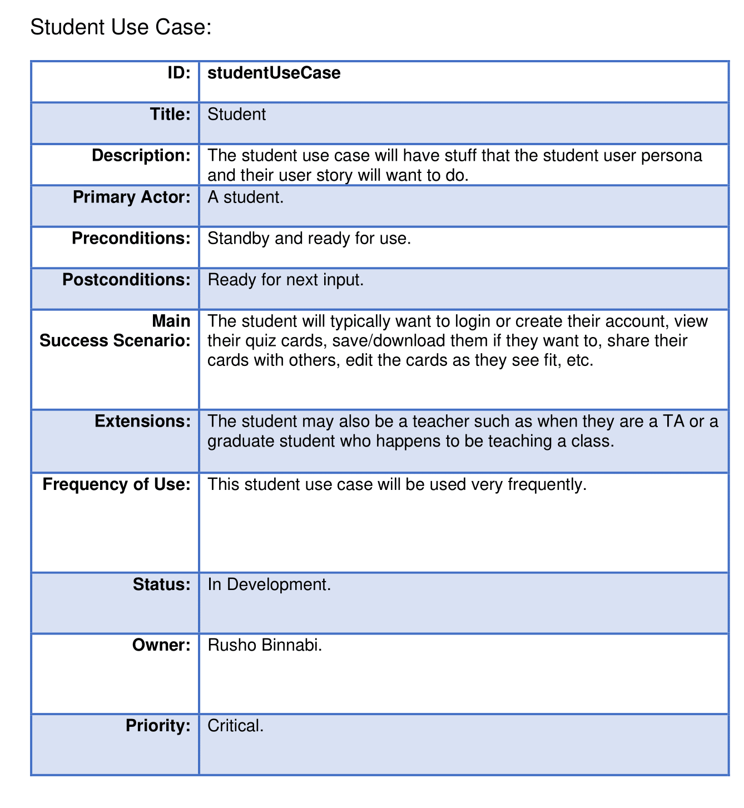
* IT
  + User feedback sources
  + A help section
  + Access to server logs
  + Notify users of shutdown and changes to the website
  + Temporary server shutdowns

# Use cases of 5 critical requirements

* Easy Maintenance

|  |  |
| --- | --- |
| **ID:** | Easy Back-end up work |
| **Title:** | A system for shutting down and working on backend |
| **Description:** | This will allow user to have easy access to the backend without interfering with users |
| **Primary Actor:** | IT Users |
| **Preconditions:** | Successful server shutdown |
| **Postconditions:** | Backend code is modified |
| **Main**   **Success Scenario:** | 1. User successfully shuts down server  2. User modifies backend code  3. Server is restarted at appointed time told to users |
| **Extensions:** | Be able to inform users about the time that the server will be shutdown and restarted |
| **Frequency of Use:** | Hopefully infrequently, but could have more use on initial launch |
| **Status:** | Developing plan for code structure |
| **Owner:** | Matthew Niemczyk |
| **Priority:** | High |

* Flashcard File System

|  |  |
| --- | --- |
| **ID:** | **FlashCardFS** |
| **Title:** | A system for managing sets of flashcards |
| **Description:** | This will allow user and especially teacher to group possibly common flashcards into folders. |
| **Primary Actor:** | General Users |
| **Preconditions:** | Successful login |
| **Postconditions:** | File System for flashcards is modified. |
| **Main**  **Success Scenario:** | 1. User creates new folder, or selects an already created one.  2. They create a new flashcard set for the folder.  3. Or they select one of their other flashcard sets to be added.  4. The flashcard set is added to the folder. |
| **Extensions:** | 1. This can be extended to create a class or folder of flashcards shared by teacher to students.  2. User provides invalid input (bad folder name, or no flashcard set selected to add to folder) - Instruct user to provide proper name or select a proper set of flashcards. |
| **Frequency of Use:** | Depends on the user:  Teachers will use it very frequently, but other users will use it much more infrequently. |
| **Status:** | Developing plan for code structure |
| **Owner:** | Mendel Rubin |
| **Priority:** | High |

Memorization Exercises

|  |  |
| --- | --- |
| **ID:** | MemTesting |
| **Title:** | Engage in memory testing exercises |
| **Description:** | This describes the process of handling the user interactions as they participate in various memory exercises. |
| **Primary Actor:** | Independent Learner |
| **Preconditions:** | - Successful login  - Topic created / Information entered |
| **Postconditions:** | - The user’s progress is updated  - Improvement suggestions are created / updated |
| **Main**  **Success Scenario:** | 1. User chooses which method they want to use to test their memory  2. System generates a new version of the chosen exercise  3. System keeps track of correctness as user completes the activity  4. User is given feedback based on their performance  5. System stores the user’s progress for the given topic |
| **Extensions:** | 1) System doesn’t recognize input  - Instruct user to change their input  2) User attempts to generate exercise using an empty set  - Warn user that their current topic is an empty set |
| **Frequency of Use:** | Very often, almost every time website is used |
| **Status:** | Developing plan for code structure |
| **Owner:** | Danica Porter |
| **Priority:** | High |

* Share sets between users

|  |  |
| --- | --- |
| **ID:** | SharedSets |
| **Title:** | Sharing and Sending Sets between Users |
| **Description:** | This will allow the different users to share the sets that they have created between one another. |
| **Primary Actor:** | General users |
| **Preconditions:** | - Successful login  - Pre-created CardDeck(s) on one user's profile. |
| **Postconditions:** | - Dual access to CardDeck(s).  - Owner controls visibility and editing settings. |
| **Main**  **Success Scenario:** | 1. User opens a CardDeck or a folder of CardDecks. 2. They select that they want to share the Decks. 3. They choose how they want to share the deck (shared memory, txt file, or link). 4. The preferred deck format is sent to the other user. |
| **Extensions:** | 1. Allow original Owner to control visibility and editors. 2. Allow non-owners to create a copy of the Deck. |
| **Frequency of Use:** | Moderately frequent, approximately once every few user sessions. |
| **Status:** | Developing plan for code structure |
| **Owner:** | Danny Peck |
| **Priority:** | High |

* User authentication:
  + 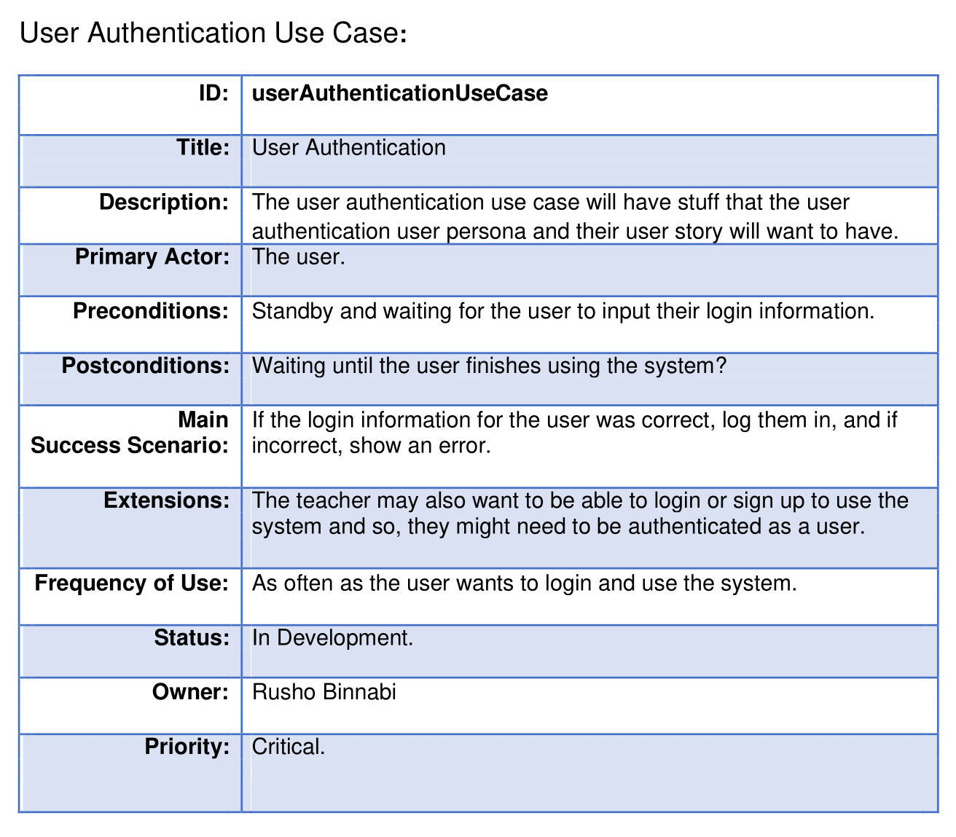

# Non-Functional Requirements:

* Efficiency:
  + Will be running with MongoDB's free cluster, so we should optimize for space efficiency to allow for maximum storage with 1 TB.
  + Time efficiency will be less important as each operation is free on the cloud, but we will do our best to keep it to a minimum to reduce wait times and energy impact.
  + Handle 100 users (for now)
* Portability/delivery/interoperability:
  + This will be delivered as a web service, so we should make sure that it works on the three major browsers: Chromium, Firefox, and Safari.
  + Maybe work on mobile LATER
* Privacy, safety, and security:
  + No immediate legal issues.
  + Keep email and passwords properly secured.
  + Keep minimal user data to reduce potential harm in the event of a cyber-attack.